|  |
| --- |
| Photo displaying partial image of two pie charts on a canvas-textured page |
| Data Visualization Project  Features of Tableau |
| |  |  |  | | --- | --- | --- | | Reonne Benoy A00268832 | 4/26/20 | Data Visualization | |

Contents

Data Sources 1

Steps to establish connection to a data source 2

Connecting to Excel Workbook 2

Connecting to Text File 2

Connecting to Database 3

Connecting to Websites 4

Connecting to Tableau Server 4

Advanced Visualisation 5

Steps 5

Maps 7

Steps 7

Steps for Covid-19 map generation (Affected areas) 7

Tableau

# Data Sources

Tableau offers a large variety of data source options that can be connected to, for fetching data. The data sources include files, relational databases, non-relational databases, big data, excel data, cloud data, etc. Tableau supports data connectors like MemSQL, Hadoop, SQL Server, Oracle Server, MySQL Server, MongoDB BI Server, Google Sheets, etc. A secure connection can be established to the data sources through tableau and data can be retrieved for visualization.

## Steps to establish connection to a data source

### Connecting to Excel Workbook

1. Open Tableau Desktop
2. Under ‘Connect’ on the start page, click Excel.

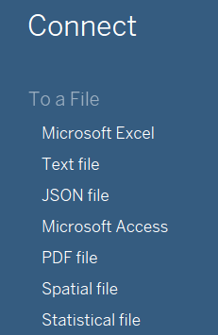

1. In the dialog box enter the path in the file field, with the format and path on the system.

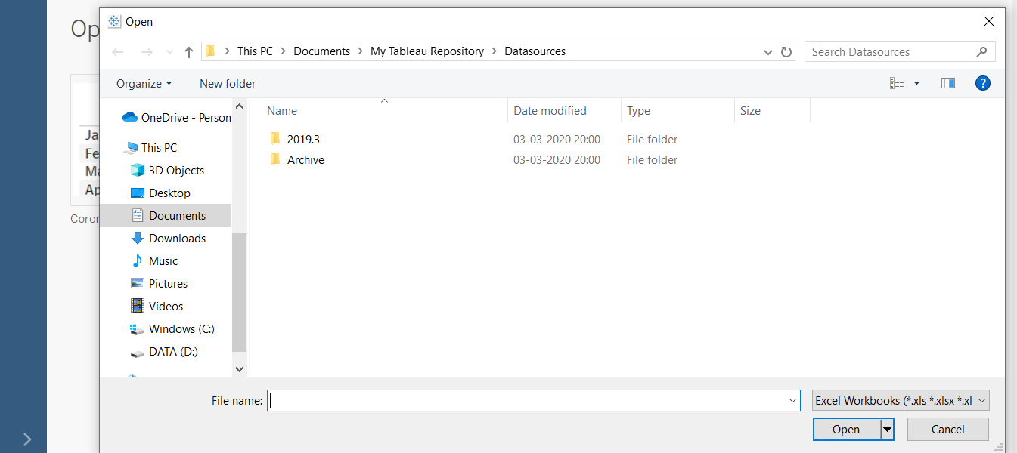

1. Select the Excel Workbook and Click on open.

### Connecting to Text File

1. Click on “Text File” option in the data tab

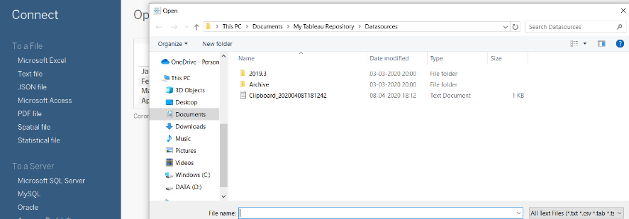

1. Select Covid-19.csv.

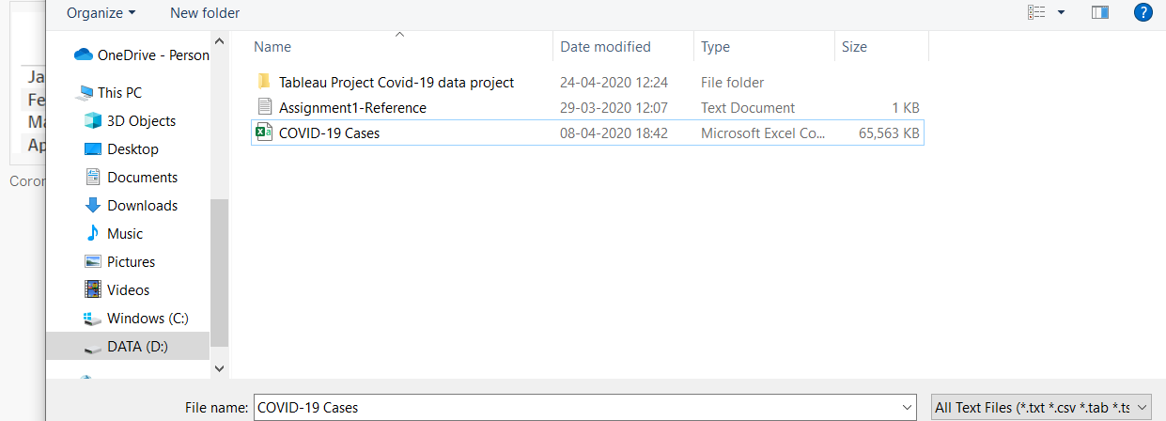

1. Click on “Open” Option and the connection will be established.

### Connecting to Database

1. Click on the required database connection given in the data tab. The options are MySQL, MongoDB, Oracle Server, etc.

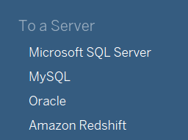

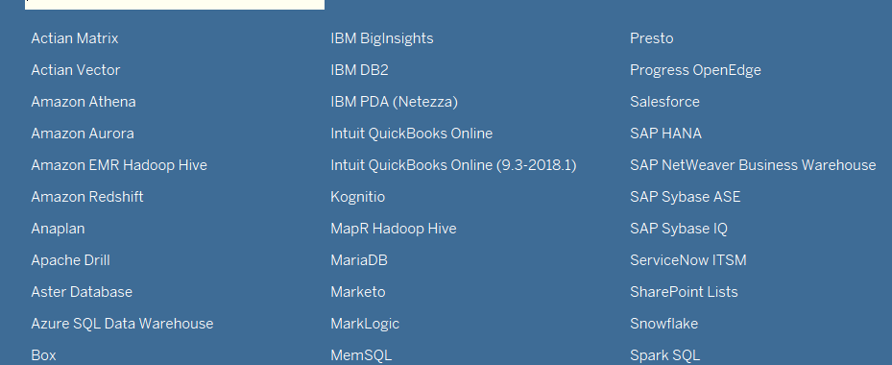

1. On clicking the option, it will open a connection window where the server name and “Port” can be entered and edited if needed. Username and password need to be entered. Then click on the sign in button.

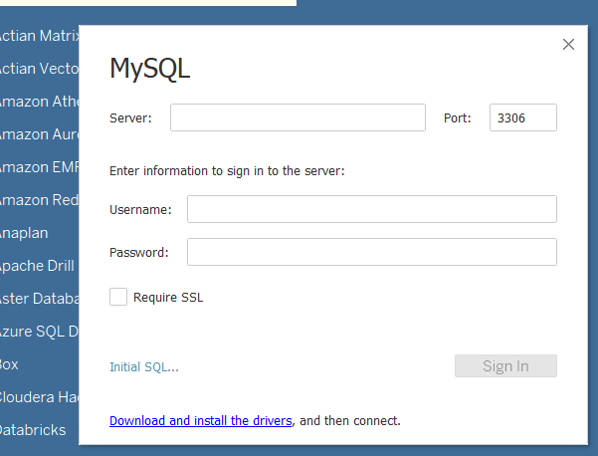

### Connecting to Websites

1. Click on the “More” option in the data tab.
2. Click on “Web Data Connector”.



1. Enter the Web Connector details and the connection is established.

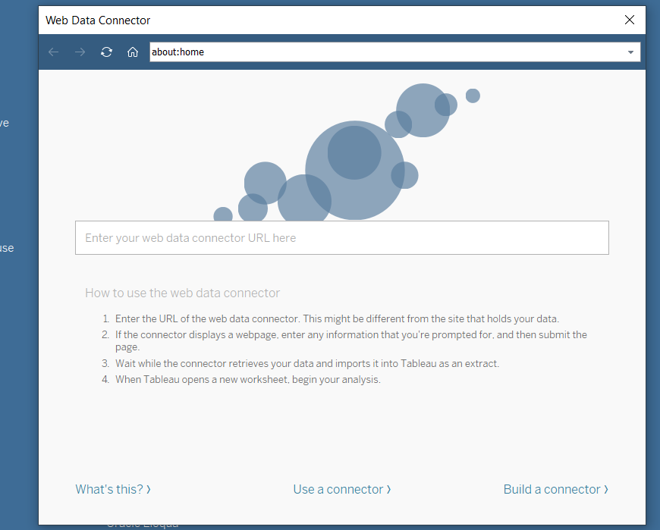

### Connecting to Tableau Server

1. Select “Tableau Server” option from data tab.
2. The Tableau Server Sign in window opens. Click on ‘Tableau Online’
3. It opens Tableau Online Sign in Window. Enter the email id and password.
4. Click on Sign in.

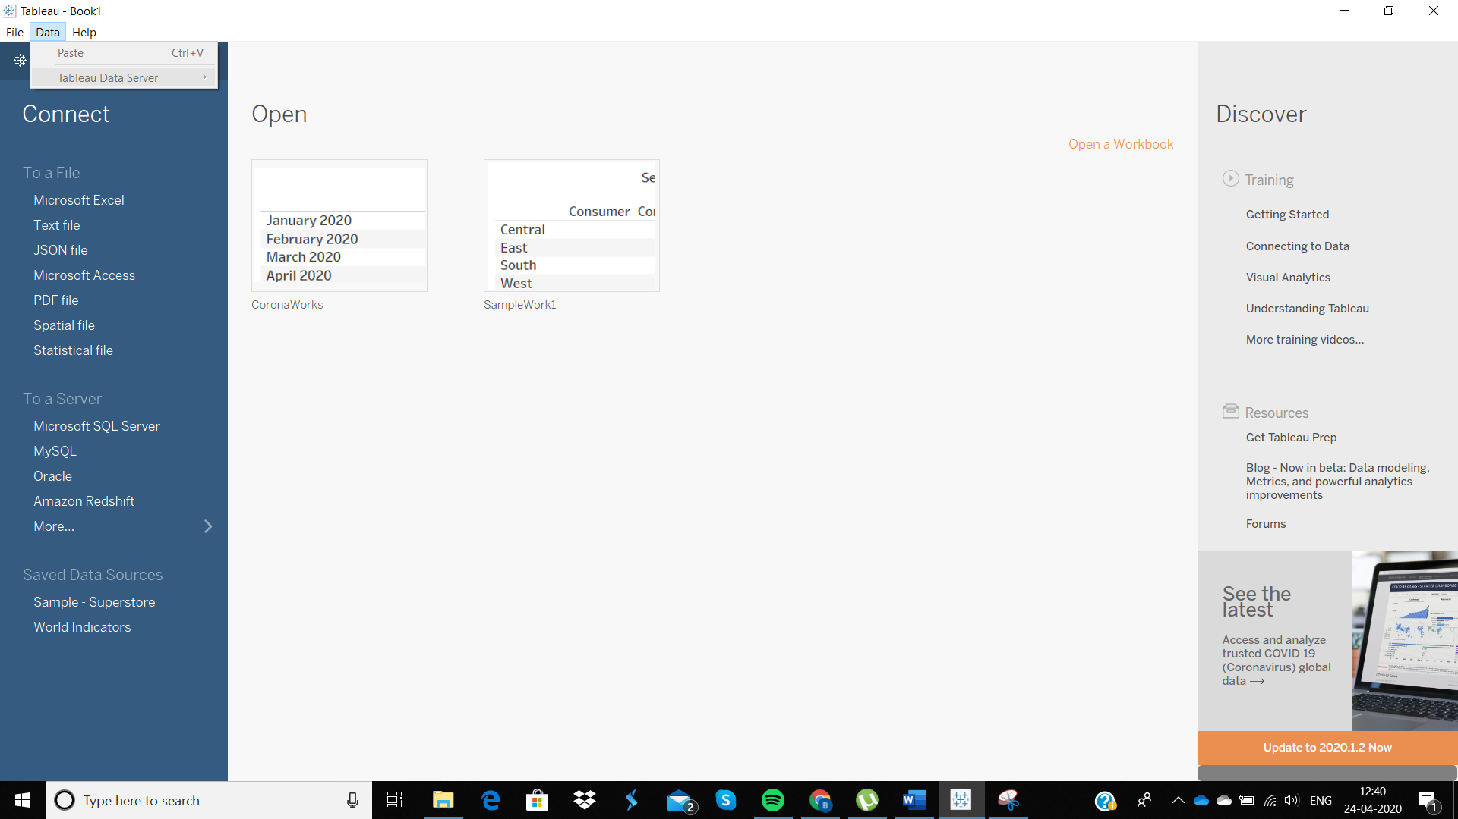

# Advanced Visualisation

Tableau has got its wide range of visualizations and it is one of the important features of tableau. Some of the visualization graphs are Bar-chart, Pie-chart, Histogram, Gantt chart, Treemap, Boxplot and many more.

## Steps

1. Retrieve the data in tableau and specify the data in Tableau.
2. After specifying the data in Tableau, we will see the Data tab on the left containing Dimensions and Measures slots. The items in the Dimension slot are the data columns being aggregated, and the items in the Measures slot are the totals of the aggregated results from the Dimensions slot. The area on the right contains cards and shelves. Here we drop the Dimension elements and the Measures elements to create the visualizations.
3. We drag the Dimension element to the shelf labelled Drop field here.
4. Table automatically visualizes the elements which are added.
5. Addition of two or more of the elements allows opens different visualization graphs. The options depend on the data type of the elements and also what we want. 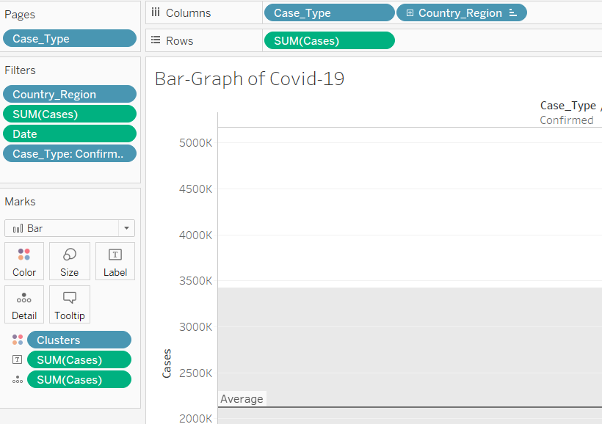
6. Towards the top-right corner, we see a drop-down option “Show me”. On clicking it, we seem to have a variety of options for visualization of the data.

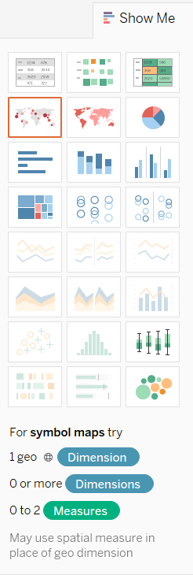

1. The options which we could select depend on the data and the data type we choose. For example, if the data we chose are category and numerical data, we have options for pie-chart, bar-chart, etc. Similarly, if we have chosen numerical data, then we will be allowed to choose only the graphs through which numerical data could be projected on and visualized like a histogram.

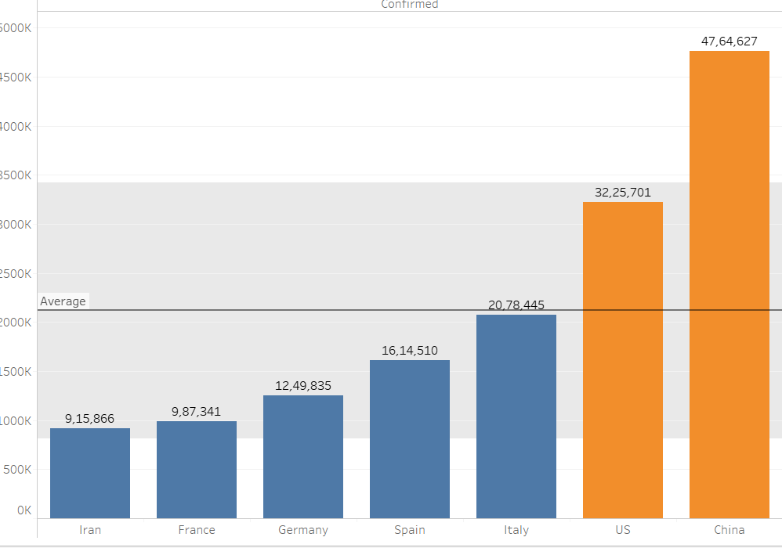

# Maps

Maps are used for geographic analysis in Tableau. There are different kinds of maps on Tableau. A prerequisite for maps is that the data must contain location data i.e., latitude and longitude coordinates. The following steps are to be followed for creation of maps on Tableau:

## Steps

1. Open through the worksheet
2. We need to select the appropriate data for creation of maps. For example, if we use 1010data, in the Data pane, under Dimensions, we see the element State. Double click and select it.

Example: Let’s demonstrate how tableau is used for map generation. The dataset we will be using for the project is the Covid-19 dataset. Let us use the dataset for map generation.

## Steps for Covid-19 map generation (Affected areas)

1. Open the dataset through Tableau worksheet. We now see the Dimensions and Measures areas on the tableau worksheet.

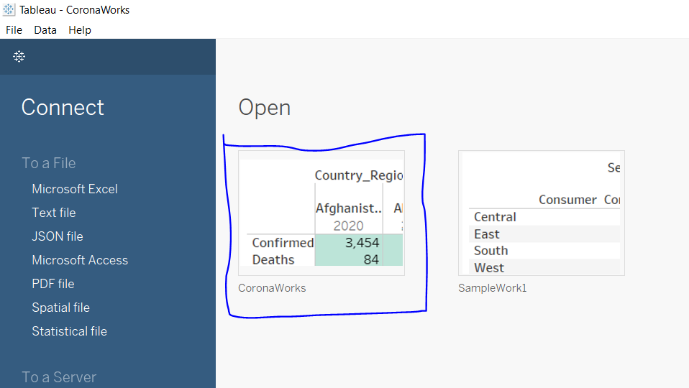 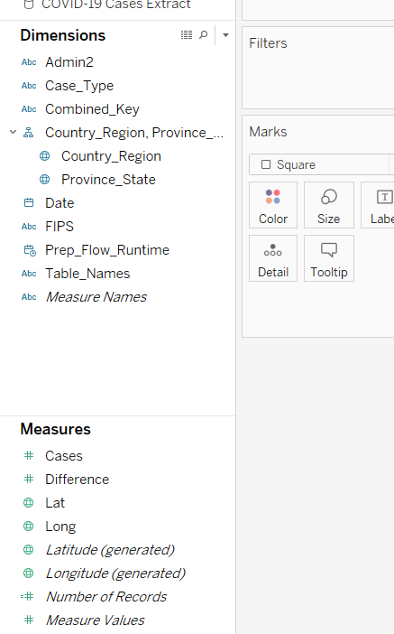

1. We add the required data fields in order to visualize through map creation. Hence, we require the location data. Therefore, we use the latitude and longitude data.

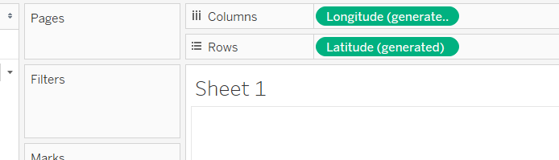

1. After we see that the map is generated, we now need to label the map accordingly for better visualization. Therefore, we add two data attributes to the marks field. We take the aggregate of all the cases and it is labelled using different colours, whereas, country and region is labelled as we mark the map using the “Country_Region” data attribute from the Dimensions area.

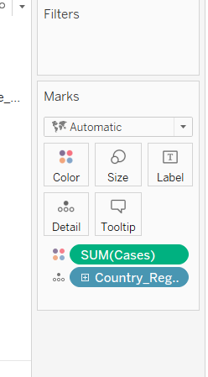

1. We see from the drop-down list of map options that there are two types of maps. We have the option to choose from either one of them provided the conditions are met.

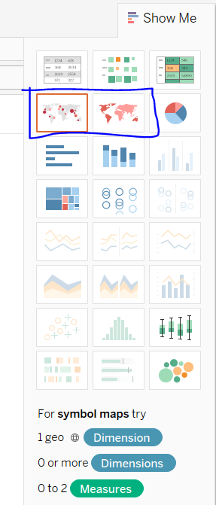

1. Finally, we get out whole map which visualizes data

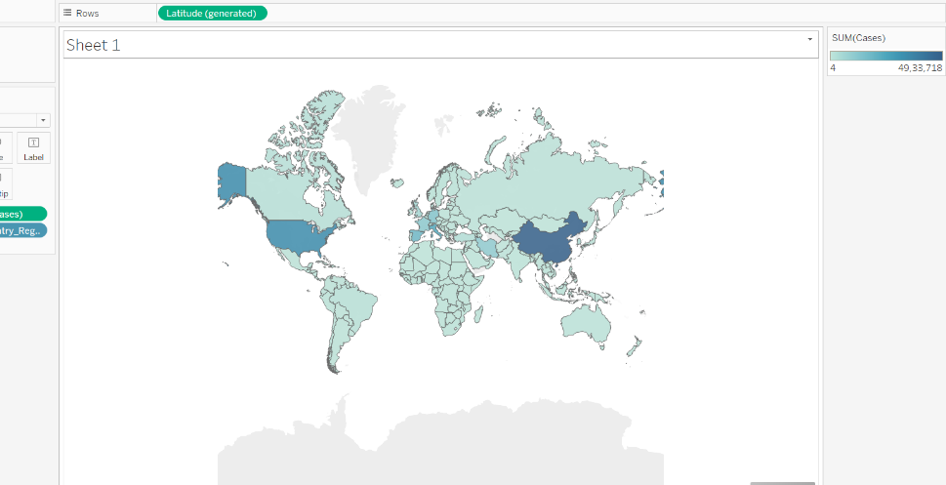

1. If we hover over the countries, we see the number of cases and the country name.

